Apache Spark

py -0

using python 3.10 with environment variable.

py -3.10 -m venv spark-evn
activate virtual environment folder

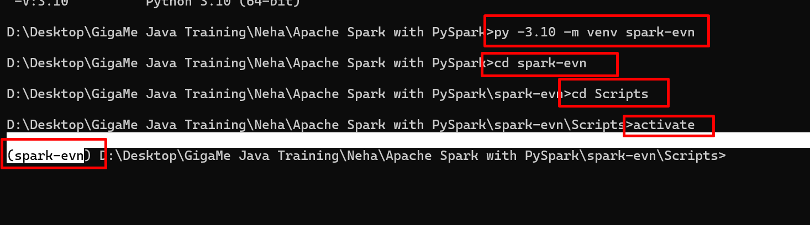

Now we will install pyspark module

python -m pip install pyspark==3.5.1
Python Core provided one the module

Spark DataFrame modules
A data frame is another spark modules which provide a features as distributed, tabular data structured in Apache spark similar to table in database. Data Frame is like a pandas but for large and distributed.
Simple way
Rows + Columns + Schema (structure).

RDD Vs DataFrame
Map map() select()
Filter filter() filter()
Aggregation reducebyKey() groupB().agg()
Sorting sortBy() orderBy()
Preview take show
collect

Apache Spark SQL Modules
Apache Spark SQL modules allow to use query data using SQL syntax. Run SQ query on DataFrame. It provide features as to combine SQL + Python login in pyspark environment. This query we are running in distributed environment.

